Young Innovators Fellowship Programme
Hiring today’s innovators, developing tomorrow’s leaders!
Do you have the drive to lead change, and want to develop your skillsets to do so?
Do you want to advocate for the rights of young people in your country?
Do you have the passion to drive innovation in the UN?
If you have answered yes, then we invite you to apply to our Young Innovators Fellowship Programme!
UNFPA is seeking twelve of the brightest and most ambitious youth globally to be a part our Fellowship Programme. Our opportunity-of-a-lifetime programme covers expenses related to travel, stipend, accommodation and health insurance.
This exciting development opportunity will see fourteen fellows join us at UNFPA Headquarters in New York for a period of two months (April-May 2019) where fellows will undergo leadership training. Twelve fellows will then move to their Country Offices for a period of six months, in a capacity most relevant to their experience, while two fellows will remain at HQ.
UNFPA recognizes the untapped potential of young people around the world. We want to channel your energy and creativity to develop innovative solutions in our Country and Regional Offices.
Our goal is to provide you with the essential tools, skillsets and international experience that will empower you to realize your career goals; we are looking for you to provide us with innovative insights and ideas that will enable us to be better aligned with youth-problems in your community
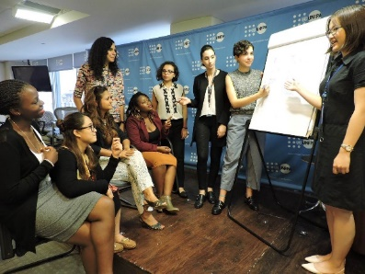
Young Innovators Fellowship Programme - Delivering on UNFPA’s Innovation Strategy

The Fellowship programme will help support delivery in our Country Offices of four strategic pillars outlined in UNFPA’s Innovation Strategy:

- mHealth: new mobile technologies to increase access to sexual reproductive health (SRH) services for adolescents and young people
Group of seven fellows seated looking at a flip chart, while two fellows present, pointing at the flip chart
- Last mile for SRH commodities: overcoming our distribution challenges to ensure access to SRH services in remote or hard to reach areas
- Data: Using innovative systems, technologies and demographic intelligence to improve population data systems and address inequalities for more effective development policies
- Innovative fundraising: Exploring possibilities of fundraising through innovative partnerships, financial platforms and instruments and face-to-face fundraising activities.

Eligibility Criteria:
- Demonstrated interest and dedication to development issues in areas of UNFPA’s mandate through either volunteer experience, work experience, or youth network affiliations
- Demonstrated, or clear idea of, delivery of UNFPA’s mandate in an innovative way
- Working knowledge of English
- Aged between 18 years to 29 years old
- Special consideration will be given to indigenous people, persons with disabilities and LGBTQI candidates

A word from some of our previous fellows:
“It has been a transformative journey, and I am still growing!”
“The exposure and knowledge the fellowship has given me will be harnessed by young people in my country. I hope to share a lot with the young people in my country, to make our lives better.”
“It was a conducive environment, because we were treated as equals.”

“Best thing that ever happened” “It is designed for social change” “It’s perfect- very collaborative”

Reasonable accommodation:

The UN system is committed to creating an inclusive workplace, and commits to taking appropriate measures to enable persons with disabilities to access employment opportunities and benefit equally from employment-related opportunities by providing reasonable accommodation. In this context, “reasonable accommodation” means necessary and appropriate modification and adjustments not imposing a disproportionate or undue burden, where needed in a particular case, to ensure to persons with disabilities the enjoyment or exercise on an equal basis with others of all human rights and fundamental freedoms. Should applicants need reasonable accommodation arrangements to facilitate their interview and assessment during the recruitment and selection process, please submit your request with your application.

Please click here for further information, and details on how to apply.

